Practical information

ARRIVAL
Train: Central station (Praha Hlavní nádraží)
To get to the venue: National Museum (Národní muzeum) is within walking distance from the train station, or take one stop by Metro to “Muzeum”
To get to the accommodation - for hotel Diplomat, take Metro line C to “Muzeum” and change to line C in the direction “Motol”, get off at “Dejvická”

Plane: Vaclav Havel Airport, Ruzyně
Only bus connection to the city
To get to the venue: Bus AE to Central train station or bus 119, then Metro line A to “Muzeum”
To get to accommodation (hotel Diplomat): Bus 119 to final stop “Veleslavín”, then Metro line A to “Dejvická”

VENUE
National Museum
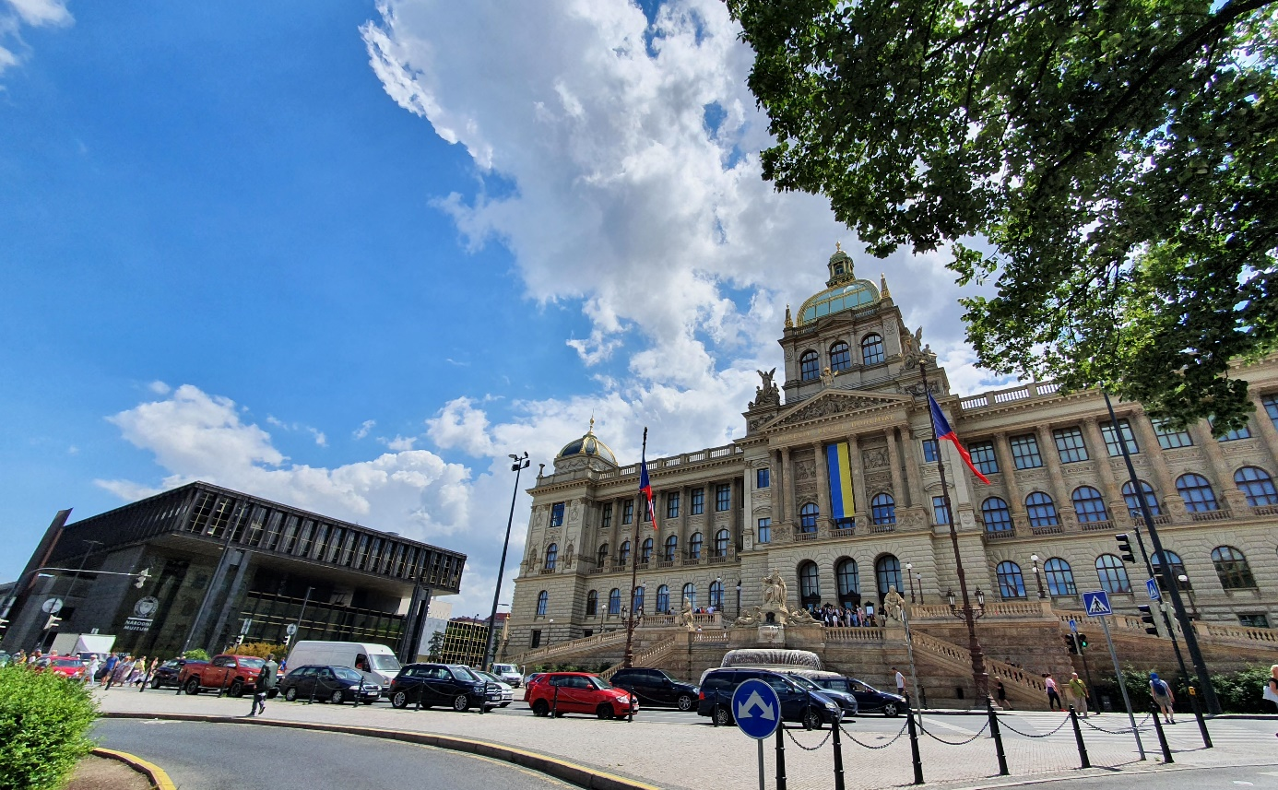

New Building Old Building
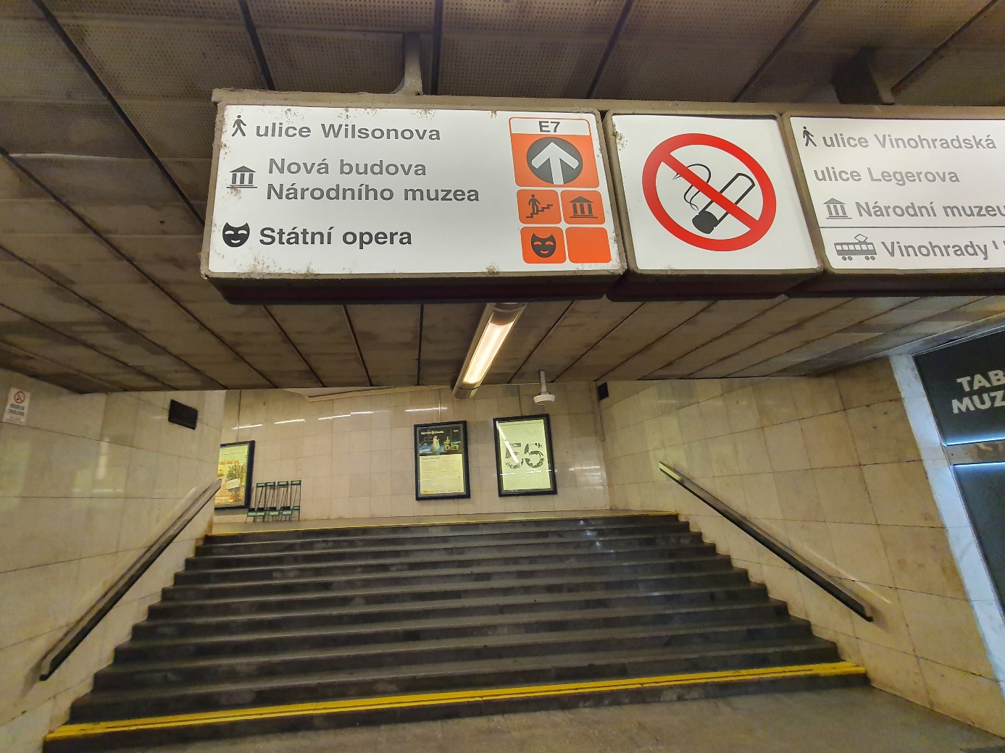

The conference will take place at the New Building, National Museum. Arriving by Metro, after leaving the escalator, go left and search for the sign “NOVÁ BUDOVA” or “WILSONOVA” (opposite Albert supermarket). The last exit E7 leads you straight in front of the New Building of National Museum.

ACCOMODATION
Participants can use pre-booked hotel Vienna House Diplomat Prague situated conveniently at the Metro line A, near station Dejvická, with a fast and direct connection to National Museum, easily accessible from/to the airport or the Prague Castle.

DINNER
All participants are invited to an informal dinner starting at 7:30 PM at Martinický palác near the Prague Castle at Hradčany. There will be buses leaving from Hotel Diplomat at 7 PM. Participants can also use public transport (tram line 22), tramstop “Pohořelec” and walk down towards the Castle, the palace (Martinický palác) is situated at Hradčanské náměstí on the corner leading to/from Kanovnická street. After the dinner, transport back to the hotel will also be provided.

