European Capital of Culture 2028 „Questions and Answers“

- The application has to be in English, and in Czech language – is it desirable? With the same number of copies?
As indicated in the call published by the Ministry: “The application shall be written in one or more of the official languages of the European Union, and one of the languages must be English. […] The English version of the applications will be the working version for the panel established to carry out the selection procedure”. It is up to each city to decide whether they want to add a version in another language than English, such as Czech. Regarding the number of copies, we would need twenty paper copies in English and, where relevant, three paper copies in Czech.

- Must the applications strictly follow the version of the questionnaires published on the Ministry’s website? Can bidding cities number questions or must them let them in form of bullets?
Annex 1 of the call specifies „Candidate cities must clearly answer all the questions below. For each section (1 to 6) questions can be answered separately or jointly.” Candidates can number question or let them in the form of bullets as long as they clearly answer all the questions.

- The pre-selection questionnaire included in Annex 1 indicates “Introduction – General considerations (max. 3 pages).” Does it mean that it is not allowed to go beyond this maximum of three pages to cover the four questions included in this introductive chapter?
The maximum of 3 pages specified in the pre-selection questionnaire for the introductory part of the pre-selection bid-book is indicative. Its aim is to help candidates in maximising the use of the 60 pages at their disposal for their pre-selection bid-book. Only the limit of 60 pages in A4 format for pre-selection (respectively 100 pages in A4 format for final section) as indicated in the call under “Formal criteria of the application” is strictly mandatory.

- Is it allowed to use the inner front cover and inner back cover of the bid-book? If so, will it be included in the pre-selection bid-book’s 60-page limit?
It is indeed allowed to use both the inner front cover and inner back cover. The inner front cover and inner back cover will not be included in the 60-page limit providing that they are not used to answer questions included in the questionnaire.”

- The intention to apply must be communicated in writing to the Ministry - the form of this written communication is arbitrary or given? It can be an email or a letter with the information?
There is no specific format (letter or e-mail), but it should come from someone representing the candidate city. The aim of this obligation is just to know in advance the number of candidates so that the Ministry can arrange the agenda of the pre-selection meeting well in advance, and inform panel Members.

- The language of declaration of honour?

The language of declaration of honour can be only in English language.

- The time limit of the hearing?

An oral presentation by each candidate city, giving an outline of its candidature, with a time limit of 30 minutes, a question/answer session between the Panel and each candidate city, with a time limit of 30 minutes.

- How would it be seen by the jury if both English and Czech version are published (in the 1st round) in one book of 120 A4 pages?

Candidate cities can decide to publish the English and Czech versions together in one single bid book of 120 A4 pages (for the first round), instead of two separate books. The two linguistic versions must however follow one another so that it is easy to check the size limit is fully respected. From a practical point of view, it may however not be optimal for panel members as bid books will then be heavier to manipulate.

- The technical equipment of the meeting room
The meeting room Konírna at the Ministry of Culture has a 1024 x 768 resolution projector with VGA (D-SUB) and HDMI connections. You have to bring your own laptop or we can lend you a Lenovo Thinkpad 430 (it should be enough for the presentation). We have there one pair of speakers and 2 – 3 wireless microphones. Konírna is 169 m2. The structure is there, with a projector hanging on it. This structure is 3,5 m from the floor.

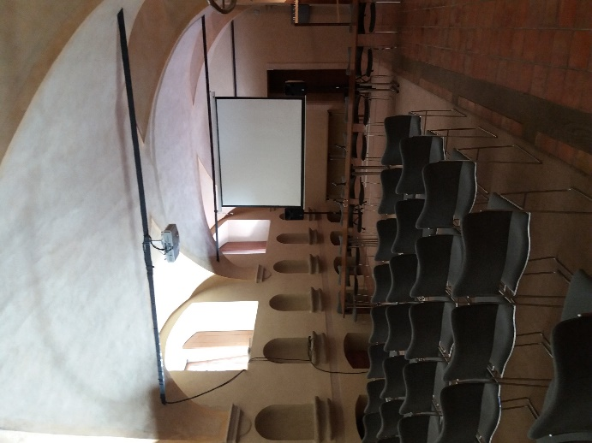

- Submission of applications

There is a possibility to submit the applications in person to the Ministry of Culture (Maltézské náměstí 1, Praha 1). You have to receive the confirmation of receipt. The number of copies is 20 in English language. It is up to each city to decide whether they want to add a version in another language than English, such as Czech language. You have to submit the digital copy at the deadline (epodatelna@mkcr.cz)

- The Panel does not want any pictures taken of them during the presentations.

- It isn´t necessary to send in additional copies of the declaration of honour. Just make sure that it is sent digitally as well.

- The time limit of the hearing?

An oral presentation by each candidate city, giving an outline of its candidature, with a time limit of 30 minutes.
At the request of the European Commission and the panel, a question/answer session between the Panel and each candidate city, with a new time limit of 60 minutes.

